Need a ride to work or MCC?

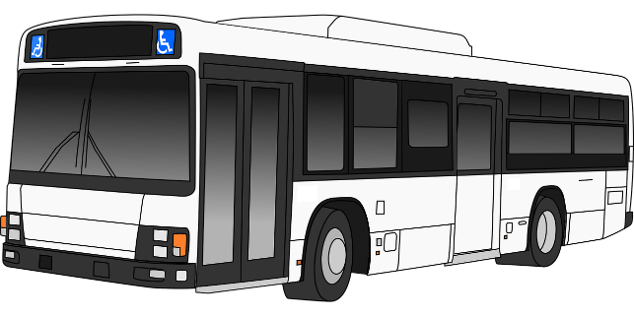

Free Highlander Bus Passes are available now in the MCC Business Office (Administration Building, 1st floor).
MCC is collaborating with Waco Transit’s public bus system to give all current MCC students a free Highlander Bus Pass good for any of Waco Transit’s fixed bus routes. https://www.waco-texas.com/transit/routes.asp
If you have questions, go to www.mclennan.edu/bus or visit the MCC Business Office.
The Free MCC Student Bus Pass program is paid for by a grant from the Cooper Foundation.

